Necessary Formulas:

- Gini Index, G = 1 – ∑ p_{i}² |; i = 1 to k, where k = number of classes.
- Average Gini Index, G_{New} = 1 – (1/N) ∑ V_{ij}²/S_{j |};
i = 1 to k, where k = number of classes and
j = 1 to n, where n = number of unique values for an attribute
- Reduction in Gini Index, R_{g} = G_{Start} – G_{New}

Iteration 1 (For Selecting the Root Node)

There are 4 instances with classification 1, 5 instances with classification 2 and 15 instances with classification 3. So, p₁ = (4/24), p₂ = (5/24) and p₃ = (15/24).

G_{Start} = 1 – (p₁² + p₂² + p₃²)
= 1 – ((4/24)² + (5/24)² + (15/24)²)
= 0.5382

Now, we need to calculate G_{New} for each of the attributes.

Frequency Table for Age  Age = 1 Age = 2 Age = 3  Class 1 2 1 1  Class 2 2 2 1  Class 3 4 5 6  Sum 8 8 8 | Age = 1 : (2² + 2² + 4²)/8 = 3  Age = 2 : (1² + 2² + 5²)/8 = 3.75  Age = 3 : (1² + 1² + 6²)/8 = 4.75  G_{New} (Age) = 1 – (3 + 3.75 + 4.75)/24  = 0.5208
Frequency Table for SpecRx  SpecRx = 1 SpecRx = 2  Class 1 3 1  Class 2 2 3  Class 3 7 8  Sum 12 12 | SpecRx = 1 : (3² + 2² + 7²)/12 = 5.1667  SpecRx = 2 : (1² + 3² + 8²)/12 = 6.1667  G_{New} (SpecRx) = 1 – (5.1667 + 6.1667)/24  = 0.5278
Frequency Table for Astig  Astig = 1 Astig = 2  Class 1 0 4  Class 2 5 0  Class 3 7 8  Sum 12 12 | Astig = 1 : (0² + 5² + 7²)/12 = 6.1667  Astig = 2 : (4² + 0² + 8²)/12 = 6.6667  G_{New} (SpecRx) = 1 – (6.1667 + 6.6667)/24  = 0.4653
Frequency Table for Tears  Tears = 1 Tears = 2  Class 1 0 4  Class 2 0 5  Class 3 12 3  Sum 12 12 | Tears = 1 : (0² + 0² + 12²)/12 = 12  Tears = 2 : (4² + 5² + 3²)/12 = 4.1667  G_{New} (SpecRx) = 1 – (12 + 4.1667)/24  = 0.3264

Rg (Age) = G_{Start} – G_{New} (Age) = 0.5382 – 0.5208 = 0.0174
Rg (SpecRx) = G_{Start} – G_{New} (SpecRx) = 0.5382 – 0.5278 = 0.0104
Rg (Astig) = G_{Start} – G_{New} (Astig) = 0.5382 – 0.4653 = 0.0729
Rg (Tears) = G_{Start} – G_{New} (Tears) = 0.5382 – 0.3264 = 0.2118

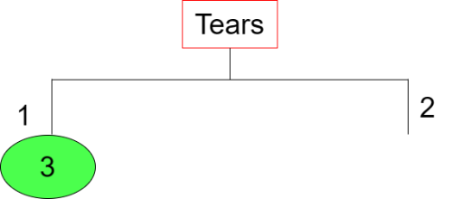

Iteration 2 (For Branch Tears = 2)

There are 4 instances with classification 1, 5 instances with classification 2 and 3 instances with classification 3. So, p₁ = (4/12), p₂ = (5/12) and p₃ = (3/12).

G_{Start} = 1 – (p₁² + p₂² + p₃²)
= 1 – ((4/12)² + (5/12)² + (3/12)²)
= 0.6528

Now, we need to calculate G_{New} for each of the attributes.

Frequency Table for Age  Age = 1 Age = 2 Age = 3  Class 1 2 1 1  Class 2 2 2 1  Class 3 0 1 2  Sum 4 4 4 | Age = 1 : (2² + 2² + 0²)/4 = 2  Age = 2 : (2² + 2² + 1²)/4 = 2.25  Age = 3 : (0² + 1² + 2²)/4 = 1.25  G_{New} (Age) = 1 – (2 + 2.25 + 1.25)/12  = 0.5417
Frequency Table for SpecRx  SpecRx = 1 SpecRx = 2  Class 1 3 1  Class 2 2 3  Class 3 1 2  Sum 6 6 | SpecRx = 1 : (3² + 2² + 1²)/6 = 2.3333  SpecRx = 2 : (1² + 3² + 2²)/6 = 2.3333  G_{New} (SpecRx) = 1 – (2.3333 + 2.3333)/12  = 0.6111
Frequency Table for Astig  Astig = 1 Astig = 2  Class 1 0 4  Class 2 5 0  Class 3 1 2  Sum 6 6 | Astig = 1 : (0² + 5² + 1²)/6 = 4.3333  Astig = 2 : (4² + 0² + 2²)/6 = 3.3333  G_{New} (SpecRx) = 1 – (4.3333 + 3.3333)/12  = 0.3611

Rg (Age) = G_{Start} – G_{New} (Age) = 0.6528 – 0.5417 = 0.1111
Rg (SpecRx) = G_{Start} – G_{New} (SpecRx) = 0.6528 – 0.6111 = 0.0417
Rg (Astig) = G_{Start} – G_{New} (Astig) = 0.6528 – 0.3611 = 0.2917

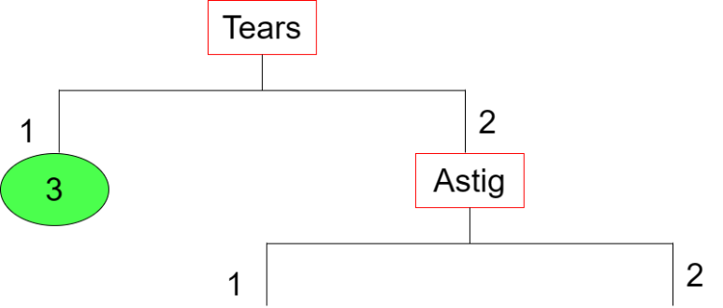

Iteration 3 (For Branch Astig = 1)

There are 5 instances with classification 2 and 1 instance with classification 3. So, p₁ = (5/6) and p₂ = (1/6).

G_{Start} = 1 – (p₁² + p₂² + p₃²)
= 1 – ((5/6)² + (1/6)² + (0/6)²)
= 0.2778

Now, we need to calculate G_{New} for each of the attributes.

Frequency Table for Age  Age = 1 Age = 2 Age = 3  Class 1 0 0 0  Class 2 2 2 1  Class 3 0 0 1  Sum 2 2 2 | Age = 1 : (0² + 2² + 0²)/2 = 2  Age = 2 : (0² + 2² + 0²)/2 = 2  Age = 3 : (0² + 1² + 1²)/2 = 1  G_{New} (Age) = 1 – (2 + 2 + 1)/6  = 0.1667
Frequency Table for SpecRx  SpecRx = 1 SpecRx = 2  Class 1 0 0  Class 2 2 3  Class 3 1 0  Sum 3 3 | SpecRx = 1 : (0² + 2² + 1²)/3 = 1.6667  SpecRx = 2 : (0² + 3² + 0²)/3 = 3  G_{New} (SpecRx) = 1 – (1.6667 + 3)/6  = 0.2222

Rg (Age) = G_{Start} – G_{New} (Age) = 0.2778 – 0.1667 = 0.1111
Rg (SpecRx) = G_{Start} – G_{New} (SpecRx) = 0.2778 – 0.2222 = 0.0556

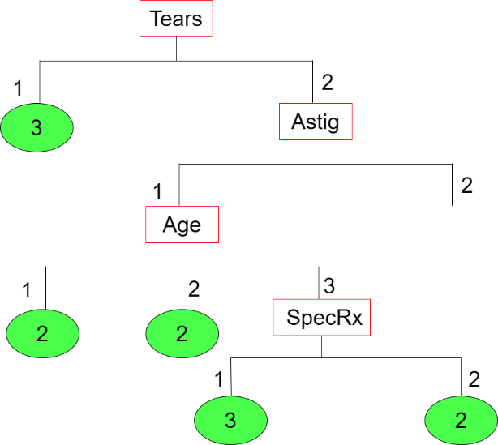

Iteration 4 (For Branch Astig = 2)

There are 4 instances with classification 1 and 2 instance with classification 3. So, p₁ = (4/6) and p₂ = (2/6).

G_{Start} = 1 – (p₁² + p₂² + p₃²)
= 1 – ((4/6)² + (2/6)² + (0/6)²)
= 0.4444

Now, we need to calculate E_{New} for each of the attributes.

Frequency Table for Age  Age = 1 Age = 2 Age = 3  Class 1 2 1 1  Class 2 0 0 0  Class 3 0 1 1  Sum 2 2 2 | Age = 1 : (2² + 0² + 0²)/2 = 2  Age = 2 : (1² + 0² + 1²)/2 = 1  Age = 3 : (1² + 0² + 1²)/2 = 1  G_{New} (Age) = 1 – (2 + 1 + 1)/6  = 0.3333
Frequency Table for SpecRx  SpecRx = 1 SpecRx = 2  Class 1 3 1  Class 2 0 0  Class 3 0 2  Sum 3 3 | SpecRx = 1 : (3² + 0² + 0²)/3 = 3  SpecRx = 2 : (1² + 0² + 2²)/3 = 1.6667  G_{New} (SpecRx) = 1 – (3 + 1.6667)/6  = 0.2222

Rg (Age) = G_{Start} – G_{New} (Age) = 0.4445 – 0.3333 = 0.1112
Rg (SpecRx) = G_{Start} – G_{New} (SpecRx) = 0.4445 – 0.2222 = 0.2223

